UK fixed gigabit broadband availability forecasts –
deployment and overbuild in the coming decade
The UK today has more broadband operators deploying more networks than at any time in the past. The introduction of infrastructure competition, the separation of Openreach and the influx of investment supported by increased demand means many consumers are now able to access at least a gigabit of downstream bandwidth and some have a choice of suppliers.
In the coming years we will see these footprints expand, at least for FTTP/B/H, and as they do so they will increasingly intersect and overbuild offering even more choice to many. Not for all however; we are expecting 17.6% of UK households to have access to only one gigabit capable network and 2.3% without any by 2030.
We have been forecasting availability coverage in the UK for some years and the latest version, laid out in this paper, is the first to be completed in the newly competitive market.

General and specific outcomes
We are projecting that the majority of UK postcodes, around 75%, will have the choice of up to three gigabit networks. There are more than 20% where the current plans and operators in the market mean four or more networks in a postcode with a small number left behind.
Figure 1: percentage of postcodes covered by gigabit networks
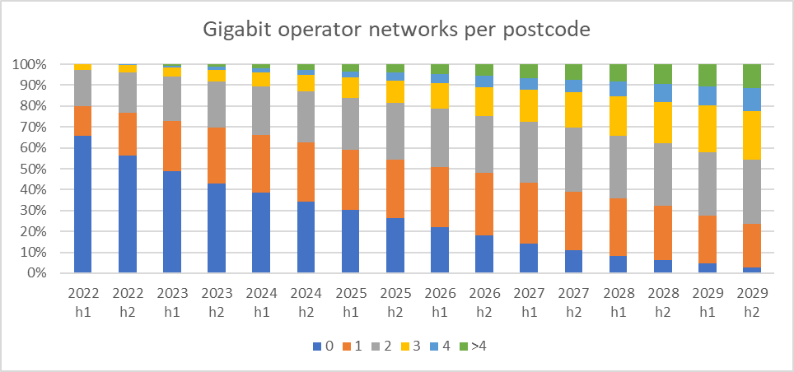
Tracking the deployments and identifying at a point in time exactly where they will be is challenging and likely to be wrong in many instances. This output is based on a model and as such does not allow for all the elements that direct deployment decisions or particular outcomes.
While we generally accept the aspirations of the operators that have stated their intentions it is unlikely that all the plans will be executed or that all the operators will survive in their current form. Reality and externalities will push plans and investment away from the original path.
However the overall outcomes, total coverage, places with multiple networks and those that are challenging and unlikely to get single or multiple gigabit offerings should be reliable.
We have tested the model by running it against historical data. The current version of the model predicts the deployment of FTTP to a postcode by any operator with an accuracy of just over 70%. Individual operators predictions vary from around 15% for smaller and newer operators to well over 70% for the more established players where we have good training data.
The next iterations of the outputs will focus on improving and reporting the results for single operators as we collate more real world input data. As deployments continue we can get a better sense of what factors are influencing their decisions, or not.

Postcode versus higher geographies
While we generate outputs at postcode level that is not necessarily the best way to use forecast outputs. Outputs from models will always be estimates and as we highlight below those outputs have varying probabilities of being correct at any particular point in time. So a general view, aggregated or averaged at a higher geography can make the data easier to interrogate or view in a map or other visual aide without significantly compromising the ‘accuracy’ of the view.
Figure 2: UK gigabit networks 2025 and 2029
One consequence of models is that we can get unexpected or unrealistic results. The maps above, at LSOA level, highlight one outcome in particular. The areas with 6 or more gigabit networks arise as different operators start to overlap more and more in the outcomes from their stated aims and targets.
This will not happen, at least not to the extent that this model predicts. As time progresses the effect of competition will start to reduce the coverage of particular operators and even threaten their existence. Understanding where this is possible or likely is useful input even if the number of networks is overstated. At the other end of the scale highlighting where there will be much lower and even no fixed gigabit coverage is useful for tracking intervention areas as well as those where more adventurous operators may be ablet to gain good market share.

Methodology
The foundational logic in the forecasting of operator deployment is to score locations based on their attractiveness - that is how profitable it would be for them to deploy in that location. There are a number of inputs that we use to determine whether a location is well suited for operator deployment in general, which make up the General Attractiveness Score (GAS).
There are also inputs which are unique for each operator derived from their stated strategy, budget, current and historical footprint and progress which combined with the GAS provide a mechanism for projecting where we believe each operator will deploy in the coming months and years.
We forecast a select number of operators individually, with the remainder collated into a single ‘other’ operator field. The list for this version is in Appendix A below. As we generate updates to these forecasts those lists will evolve as more detail and timeline emerges on each operator.
After each postcode has an indexed score from the inputs, weighted by their relevance to each specific operator, the forecast flags are generated by ordering the postcodes by their attractiveness to each operator and matching to their stated target numbers and locations where available.

Building the General Attractiveness Score (GAS)
We overlay and link a number of datasets to allow representation of time series, existing states of supply and demand, demographics, population densities and derived scoring outputs and fields all of which contribute to the forecasts of broadband availability to 2030.
Each postcode gets a score of 0 to 1 in the following fields:
Affordability (AF) - entry level monthly tariff in the postcode, indication of how much people are willing and paying for subscriptions. You can see more analysis based on this factor in our research and reporting - Gigabit Broadband Affordability in the UK (point-topic.com)
Digital Deprivation Index (DDI) - to highlight the areas most at risk from internet/broadband non-adoption. Age is a key metric here, the older an individual the less likely they are to have a broadband connection at home. We have tracked digital deprivation in the UK for more than a decade now and our analysis has proved useful in a number of real world applications - Observational cross-sectional study of the association of poor broadband provision with demographic and health outcomes: the Wolverhampton Digital ENablement (WODEN) programme | BMJ Open
Population density (PD) - consistently the best correlation with availability of services and suppliers for telecoms services. Not all operators focus on this exclusively and some fixed suppliers make a point of addressing less dense areas. Nonetheless how many customers you can address for a certain deployment is core to all deployments.
Time since last upgrade (TU) - today there is significant pent up demand in areas where the technologies and bandwidths have not kept up with other areas. An operator is likely to capture a good local market share quickly (less than 6 months) with a significant upgrade to local supply although other local conditions can affect this.
These scores will be summed to produce the 'general attractiveness' of each postcode.
GAS = AF + DDI + PD + TU
We work at postcode level for our analysis. While a number of the inputs are only published at higher geographies we allocate the values across the postcodes in the areas that are reported at. For example there are several useful indicators (income, health, presence of children) published in the Indices of Multiple Deprivation at Lower Super Output Area.

Sensitivity Metric (SM)
However, before this score is used in the forecasts, we weight each input by a sensitivity metric that is generated from UPC deployment data from the past 2 years.
The sensitivity metric is unique to each operator and is an indication of how sensitive each operator is to each input. For example all operators are sensitive to population density, so it is weighted more heavily in all cases, though some are more heavily influenced by the DDI than others, so this will be reflected in their specific attractiveness score.

Operator Specific Attractiveness (OA)
There are a number of inputs generated from the postcode databases that we predict will have a unique influence on each operator. These are summed and added to the general attractiveness score to produce an operator specific attractiveness score.
A score from 1 to 0 is generated for the following inputs:
Network Proximity (NP) - This is a score given to each postcode in the surrounding areas where the operator is already deployed. If the operator is already deployed very near to this postcode, we assume they are more likely to deploy there soon.
Overbuild (OB) - The count of operators already in the postcode. Some operators are more sensitive to this, whereas for others this input is of no obvious consequence (e.g. Openreach). We use the inverse of this score to maintain that less overbuild is more attractive.

The network proximity and the inverse of the overbuild score are then added to the general attractiveness, to produce a set of postcodes for each operator with an attractiveness score unique to the operator. Note that each set contains only the postcodes in the catchment area of each operator (see below)

OA = GAS*SM + NP + OB
Note: the sensitivity metric is multiplied by each individual input of the general attractiveness score

Research based inputs
Catchment Area - Geographic boundaries based on operator announcements. The operators are only forecast to deploy inside the areas which they have announced.
Upper Limit - The number of premises the operators have stated that they will have passed by time t and on to 2030. In many cases this is extrapolated from announcements made by operators for an earlier date.
Once all operator specific attractiveness scores have been generated for all postcodes in their respective catchment areas, postcodes are then listed in order of attractiveness with a running sum of premises generated alongside, and a flag for forecasted presence is allocated to each postcode, until the upper limit for that time step is reached.
Recursive inputs
One of the most challenging aspects of generating an accurate forecast is the nature of inputs changing over time. The most illustrative example of this can be seen with the overbuild score and network proximity.
If we use only the inputs from 2022 to generate the overbuild score, very quickly you see the locations that are generally attractive become saturated with operators. This happens if you do not take into account the change in the overbuild score from the forecast we are generating when we allocate the forecast flags for the next time step. The network proximity score comes with the same difficulty.
To solve this issue, we generate each half year recursively, which is to say that we generate the operator specific attractiveness score anew after the allocation of forecast flags in each time step. This means that when we forecast that a location will become saturated with operators, the attractiveness of that location goes down as the forecast proceeds.

The current list of operators that are picked out individually and have their own expected footprints in the full dataset is:
Figure 3: operators in the forecast models with their own projected footprints
OPERATOR
CityFibre
Community Fibre
FW Networks
Gigaclear
GNetwork
Hyperoptic
ITS FTTP
KCOM Lightstream
Openreach
Trooli
Virgin
Zzoomm

In this version the remainder are collated as ‘other’. Future iterations in 2023 will expand the list of individual operators that we break out.

Outputs, data tables and next steps
The data is available in two formats.
- A compound output that aggregates all the individual forecasts and reports the counts of gigabit networks at every half year to the end of 2029.
- We also publish the catchment areas and expected propagation for the individual operators as described above, again at postcode level by half year to the end of 2029. The remaining operators active today are collated into an ‘other’ footprint which is also published in this table.
We provide data tracking how effective and accurate the model is for each operator and as an overall aggregate. As time and deployments progress we will continually review the metrics we use to asses attractiveness and the weightings that best fit operator behaviour.
This should mean that we can improve the accuracy of our forecasts and expand the list of the operators that we can publish with individual footprints and catchment areas. At the moment we are expecting to issue quarterly updates in 2023.

Fibre to the premises or building or home – various acronyms generally the same outcome and supply

